CHAPTER 7
LC Filter

A filter is an electrical network made of components like resistors(R), capacitor(C) and inductors (L) that is used to control frequency components of a signal. Basically the output of rectifier (used to find pure dc from ac input) is pulsating dc (contains both ac and dc) and in the case of inverter (used to find pure ac from dc output) is pulsating ac (output contains lot of harmonics).without filter the current generated by the grid connected inverter contains lot of harmonics. When we injects this kind of current into the grid it deteriorates the grid voltage then hence causes lots of power quality issues.

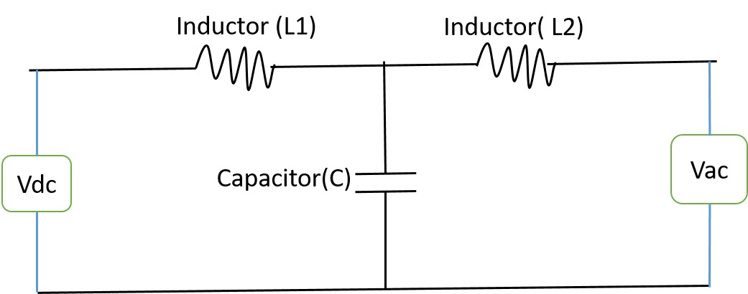

Figure: basic low pass filter.
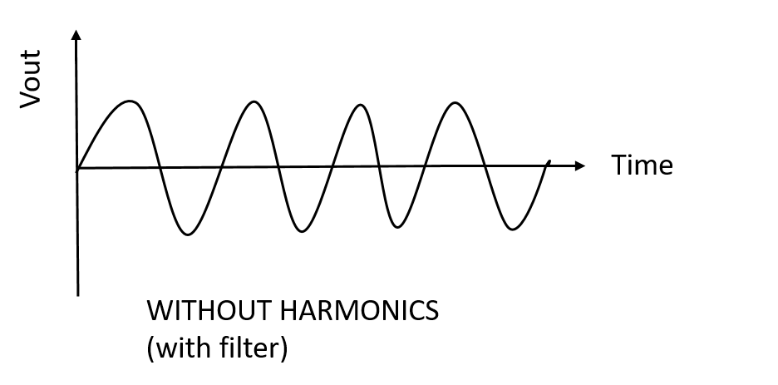
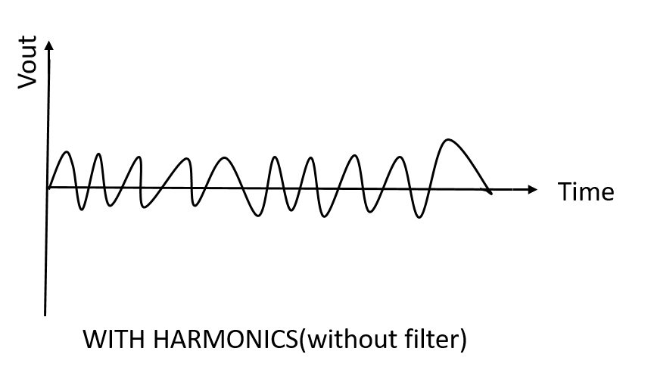

Figure: basic filter and its action

In transformer-less on grid inverter, the switching action of semiconductor devices (IGBT or MOSFET) generates harmonics in the output voltage and current. If these harmonics are directly fed into the grid, they may causes power quality issues, increased losses, electromagnetic interference (EMI) and even malfunction of different types of sensitive devices such as MRI machines, ECG monitors, programmable logic controller etc. Therefore, filters are used at the inverter output to ensure compliance such as IEEE 519 and IEC 61000.

When we use filter it suppress switching frequency harmonics and provide a near sinusoidal output. Basically it allows to pass a fundamental frequency and suppress all other frequency then there a sinusoidal output is found. It is very necessary to ensure that the total harmonic distortion (THD) remains within the allowable limits for grid connection. According to IEEE 519 standard (IEEE Recommended practices and Requirements for Harmonic Control in Electrical Power Systems) both Current and Voltage THD limits is less <=5%(often strict at <=3%).Also according to IEC 61000 standard both Current and Voltage THD limits is less <=5%(often strict at <=3%).Another advantages of using filter is that It gives protection both the inverter and the grid from high frequency stresses. Also improves the overall efficiency and power quality of the system.

There are several types of filter can be used at the inverter output to find near sinusoidal output:
1:L Filter(Inductor Filter)

An L Filter is the simplest type of output filter among different types of filter used in grid connected transformer-less inverter consisting of a single inductor in series with the inverter output. Among different types of filter its function is very simple and more reliable. Basic function is very simple which is when output of inverter is fed to the filter it suppress high frequency switching harmonies and allows to pass a fundamental frequency( which is 50 HZ in Bangladesh) therefore a pure sinusoidal output is obtained to the grid.

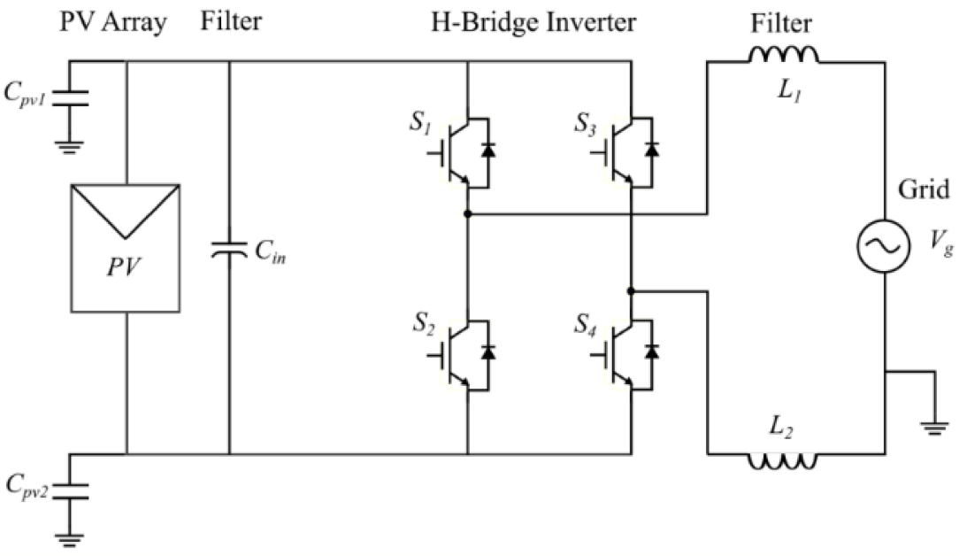
Figure: a low pass L filter

In transformer-less on grid inverters ,one of the major problem is leakage current which is flow between ground and parasitic capacitance since we didn’t provide any type of galvanic isolation (as we didn’t use transformer which is basically provides galvanic isolation between PV array and grid).But leakage current is one of the main issue in transformer-less on grid PV systems as discussed in above .In the case of leakage current L filter is very suitable because its simple series inductor limits high frequency harmonics and allow to pass a fundamental frequency without creating additional paths for leakage current therefore a sinusoidal output is found without harmonics.
Leakage current is depends on common mode voltage which is depends on switching frequency. If common mode voltage increase then corresponding leakage current increase and vice-versa. In the case of LC filter and LCL filter, there is a capacitor used in grid side which could increase common mode voltage as a result leakage current also increase. But in L filter there is no capacitor is used to the grid side as a result the issues of common mode voltage doesn’t arises.
Since L filter only used a inductor therefore there is lots of advantages over LC filter and LCL filter like reduce cost, simple design , low power loss and small size .Due to those advantages it is an efficient choice for prototype transformer-less on grid systems. Its ability to provide adequate harmonic attenuation while maintaining system safety and simplicity makes it the preferred filter for low to medium power transformer-less inverters.

2.LC Filter
An LC filter is a moderate output type low pass filter among different types of filter used in grid connected transformer-less inverter consisting of a single inductor(L) in series and a capacitor(C) at the inverter output. This combination of inductor and capacitor provides better harmonic attenuation compared to simple L filter. Basic function is very simple which is when output of inverter is fed to the filter it suppress high frequency switching harmonies and allows to pass a fundamental frequency( which is 50 HZ in Bangladesh) therefore a pure sinusoidal output is obtained to the grid.

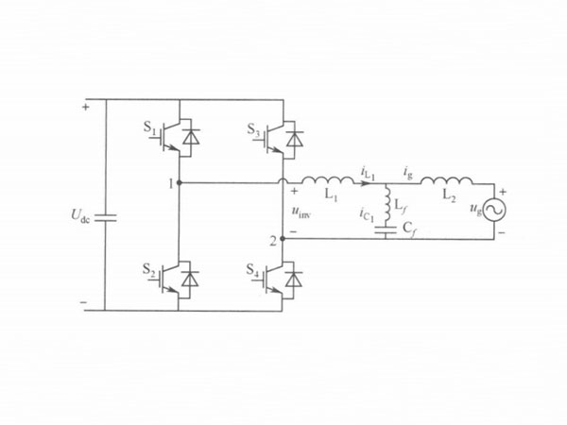
Figure: A low pass LC Filter

The capacitor helps bypass high frequency components, while the inductor limits the current ripple generated by the fast switching of power semiconductor devices (IGBT or MOSFET) as a result of better power quality and effectively reducing both voltage and current Total Harmonic Distortion (THD).An LC filter provides better harmonic attenuation compared to simple L filter makes it very suitable for systems that must comply with strict grid standards such as IEEE 519 and IEC 61000.
In the case of leakage current LC filter helps reduce this problem by attenuating high frequency switching components, which are primary contributor to the leakage. But the capacitor used in LC filter provides a path for some leakage currents. Therefore, in transformer-less inverter designs the value of inductor and capacitor have to choose so that to achieve harmonic reduction without significantly increasing leakage current.

3. LCL Filter
An LCL filter is a high output type low pass filter among different types of filter used in grid connected transformer-less inverter consisting of two series inductors (L) one on the inverter side and one on the grid side with a capacitor(C) connected between them.. This combination of two inductor and a capacitor provides better harmonic attenuation compared to simple L filter and LC filter. Basic function is very simple which is when output of inverter is fed to the filter it suppress high frequency switching harmonies and allows to pass a fundamental frequency( which is 50 HZ in Bangladesh) therefore a pure sinusoidal output is obtained to the grid.


Figure: a basic LCL filter

The inverter side inductor (L1) limits high frequency switching ripple and reduces the current changes also mitigating leakage current. The grid side inductor (L2) smooths the current injected into the grid .The shunt capacitor bypasses high frequency voltage components, further improving harmonic suppression. But in the case of transformer-less inverter this shunt capacitor provides a path for some leakage current .So in the case of LCL filter in transformer-less inverter designs the value of inductor and capacitor have to choose so that to achieve harmonic reduction without significantly increasing leakage current.

$$∇I_{pp}=ripple current$$
$$= ∆I_{max}- ∆I_{min}$$
$$Now, V_{L}=Li\frac{di}{dt}$$
$$V_{dc}-V_{out}=Li\frac{di}{dt}$$
$$V_{dc}-V_{out}=Li\frac{∆I_{pp}}{DT_{s}}$$
∆I_pp=(DT_s (V_dc-V_out))/L_i -----(i)
$$For any PWM inverter duty cycle D. at any given time is given that$$
$$D\left(ωt\right)=m_{a}*\sin\left(ωt\right) , where m_{a}=modulation index$$
$$V_{out}=V_{dc}*D$$
$$Substuttin this value into ewuation (i)$$
$$∆I_{pp}=\frac{m_{a}*\sin\left(ωt\right)*T_{s*}\left(V_{dc}-V_{dc}*m_{a}*\sin\left(ωt\right)\right)}{L_{i}}$$
$$∆I_{pp}=\frac{m_{a}\sin\left(ωt\right)T_{s}V_{dc}\left(1-m_{a}*\sin\left(ωt\right)\right)}{L_{i}}$$
$$Now to find the modulation index where the maximum ripple is present$$
$$For maximum ripple \frac{d}{dt}\left(∆I_{pp}\right)=0$$
$$\sin\left(ωt\right)=\frac{1}{2m_{a}}$$
$$∆{I_{pp}}_{max}=V_{dc}*\frac{T_{s}}{4L_{i}}$$
$$Finally, L_{i}=\frac{V_{dc}}{4*F_{SW}*∆{I_{pp}}_{max}}$$
​

Here is a basic comparison among the filter.
A direct comparative analysis between L, LC, and LCL filters based on the criteria you specified:

Comparative Table
Criteria | L Filter | LC Filter | LCL Filter
1. Complexity | ★☆☆☆☆ (Very Low) | ★★☆☆☆ (Moderate) | ★★★★☆ (High – requires careful design/damping)
2. Cost | ★☆☆☆☆ (Low) | ★★☆☆☆ (Medium) | ★★★☆☆ (High – more components & control)
3. Harmonic Attenuation | ★★☆☆☆ (Low) | ★★★☆☆ (Moderate – 2nd order) | ★★★★★ (High – 3rd order)
4. Efficiency | ★★★★☆ (High – low component count) | ★★★☆☆ (Good, some reactive losses) | ★★☆☆☆ (Lower – more losses due to components)
5. Stability | ★★★★★ (Very stable) | ★★★☆☆ (Resonance risk) | ★★☆☆☆ (Needs damping – active or passive)

Between L, LC and LCL filter we were choose low pass L filter because in bipolar HERIC topology we found best output by using this filter.

